Refitting Ben’s Data

Steve Turley, 4/6/2018

Table of Contents

Introduction 1

Initial Fits 1

Fitting Y2O3 Thickness 1

Fitting SiO2 Thickness 6

Fitting Roughness 6

Fitting Just the Index of Refraction 7

Fitting Everything 9

Refined Fits 11

# Introduction

This is a diary of what I went through to fit Ben’s data from 2015. I started by assuming the process Ben went through to assign wavelengths to the data, compute dark current, interpolate $I_{0}$, and compute reflectance were probably okay. There is at least one problem with this which I’ll address later.

My next step was to export Ben’s data to MATLAB so I could use the same fitting tools which seemed to work well on Joseph’s data. This was straightforward since Ben did a good job organizing and documenting what he did.

# Initial Fits

## Fitting Y2O3 Thickness

I started with fitting the Y2O3 index of refraction and thickness and keeping everything else at their default values. I used the CXRO index of refraction data for Si and SiO2. The default values for the roughness on the top surface was 0.7 nm and the thickness of the SiO2 was 1.8 nm. Here are the fit values of $n$, $k$, and the thickness.



Figure 1



Figure 2



Figure 3

The data are compared to the CXRO Y2O3 data from volta (at least what was there when Ben did his fit). Note that some of the thickness have anomalously different values from the others. Also note that the error bars on the thicknesses are larger at the longer wavelengths where there are less pronounced or no minima in the spectrum to constrain the fit. However the fit value of these thickness tend to agree with the other good fits.

The $θ$- $2θ$ fits were sometimes very bad and sometimes very good. The worst fit corresponds to the worst thickness at 4.5 nm.

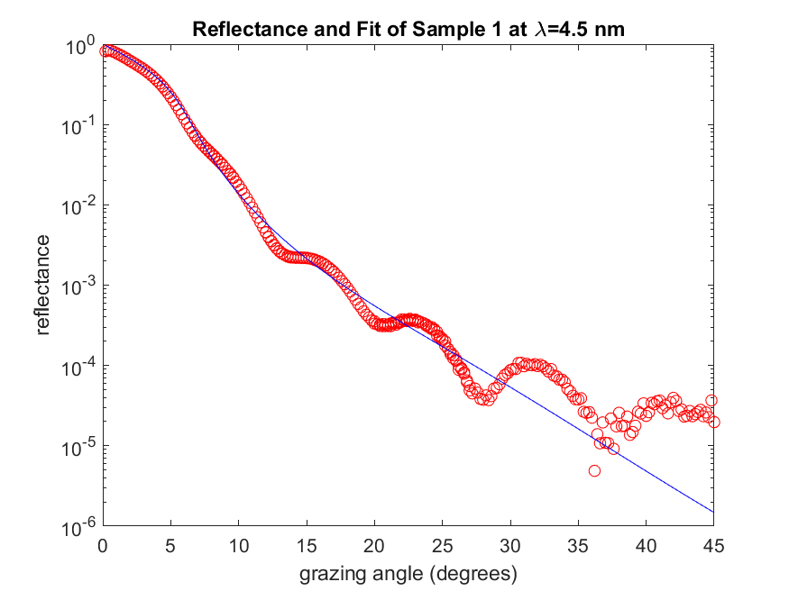

Figure 4

The fit doesn’t even being to match the maxima and minima in the data. On the other hand, the fit for 7.5 nm, though far from perfect gives me a lot more confidence that the thickness is about right.

There is an exceptionally poor fit at 5.5 nm, but two others at the same wavelength which look pretty good. The fits at 9.5 and 10 nm ahs a thickness which is far off the others, but the fits don’t look that bad.

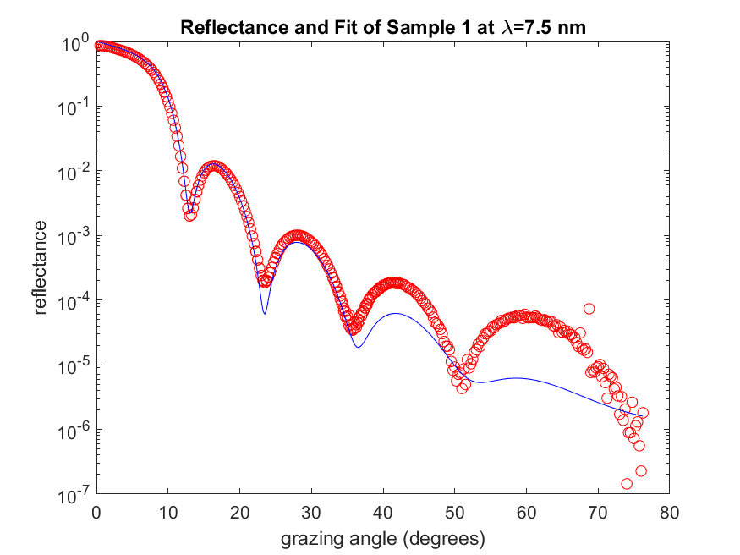

Figure 5

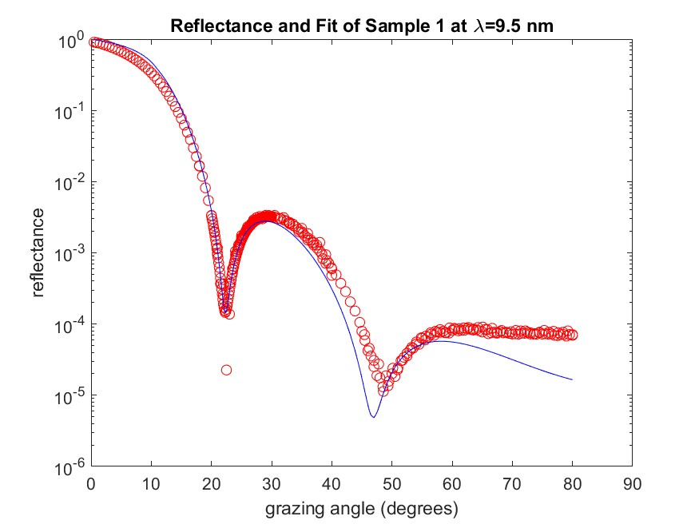

Figure 6

## Fitting SiO2 Thickness

I took a weighted average of the fit thickness which weren’t outliers and got a thickness of the Y2O3 of 16.0 nm. I then fixed that number and fit the thickness of the SiO2 layer along with the Y2O3. The quality of the first improved quite a bit, but it didn’t make much difference in the fitted values of n and k. Here is the fit thickness of SiO2.



Figure 7

There are still some outliers from the other values, but most cluster around the mean value of 2.19 nm. As before I arrived at that value with a weighted mean that ignored the outliers.

## Fitting Roughness

Next, I fixed the thickness of both the SiO2 layer and Y2O3 layer and fit the roughness of the top surface. That fit was more scattered than the others and included some non-physical negative roughness values.



Figure 8

The points which weren’t outliers had a weighted mean of 1.06 nm.

## Fitting Just the Index of Refraction

Lastly, I fixed the roughness and film thickness at their average values and fit just in the Y2O3 index of refraction. The fit wasn’t as good as when I allowed a thickness or roughness to float. Some energies were particularly bad. The values for n were close to what was fit before and to the CXRO values. The values for k on the other hand had some values which were much different than their neighbors.



Figure 9: n when only fitting index



Figure 10: k when only fitting index

## Fitting Everything

Finally, I fit all five parameters at the same time. This resulted in good consistent fits for the index of refraction, but scattered fits for the thicknesses and roughness.



Figure 11



Figure 12



Figure 13



Figure 14



Figure 15

# Refined Fits

Next, I did some tweaking on the fits at wavelengths that looked problematic. My starting point is using the fit where I only varied the index of refraction, keeping the thicknesses and roughness constant. This isn’t the best set of fits, but it is physically reasonable.

From the index of refraction graphs in Figure 9 and Figure 10, it looks like the best place to start the focus is the shortest wavelengths.

## Short Wavelengths

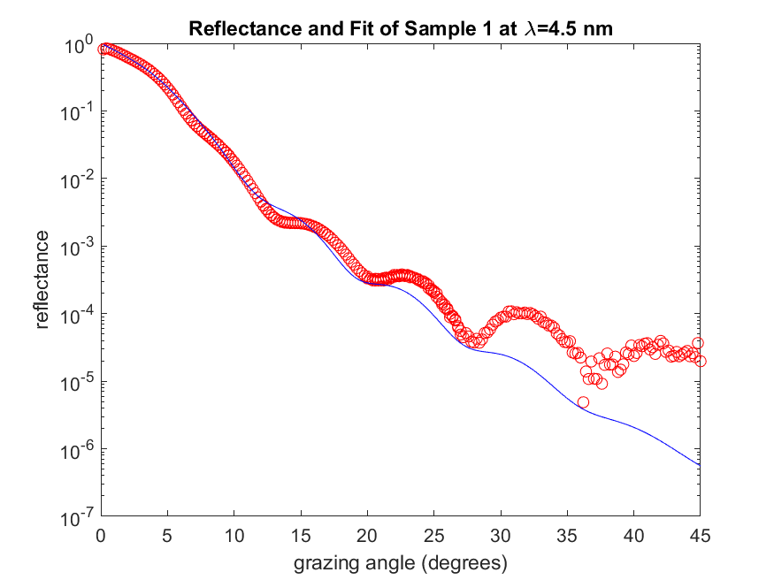

Figure 16 Data and Fit for 4.5 nm

The index of refraction values are okay for this fit, but it doesn’t fit very well at large angles. I can think of two physical possibilities. One is that the dark current is off. Another possibility is that my model is wrong and that shows up at high energies when the light is most penetrating.

Figure 17 is what the data looks like if I subtract $2×{10}^{5}$ from each point. This has more of a slope I like for higher angles. Note that this much dark current is a very small change for the highest gains. The fit, as shown in Figure 18 is qualitatively better. We can improve this even more by adding a dark current as a fit parameter.

The graphs in Figure 19 through Figure 21 show the results of refitting all of the data when the dark current was allow to be a fit parameter. Most of the dark currents in Figure 19 look reasonable, especially for wavelengths less than 20 nm.



Figure 17 4.5 nm data with higher dark current



Figure 18 Fit for 4.5 nm with added dark current



Figure 19 Dark Current from fit as a function of wavelength



Figure 20 Real part of index of refraction when dark current was fit.



Figure 21 Imaginary part of index of refraction when dark current was fit.

## Cleaning up Runs

As I looked at the problems with these fits more closely I noticed that there were multiple runs at some wavelengths and some of these fit much better than others. With multiple data points and unknown origins, I decided to average the fits when the fits all looked reasonable and to eliminate data from runs that looked very different from other others when the fits didn’t look reasonable.

### Eliminated Runs

* Run 10 (9.5 nm): Data looked very different than the other 9.5 nm run and was a very poor fit.
* Run 11(10 nm): I only have one run at this wavelength, but the high angle data is messed up to the point I can’t get a good fit.
* Run 14 (10.5 nm): Data looked very different than the other 10.5 nm run and was a very poor fit.
* Run 18 (13 nm). Data looked very different from the two runs. One fit well and the other didn’t. I kept the good fit.
* Run 23 (15 nm) Data look very different than the other two at this wavelength and don’t fit well.
* Runs 26 and 27 (18 nm): There were three runs taken at this wavelength, two of which looked very different than the others and one of which was a good fit. I kept the good fit and discarded the two others.
* Run 33 (20 nm): Both runs 33 and 34 look similar, but the density of data points for run 33 weights the low angle part of the spectrum twice as heavily as the high angle part of the spectrum.

### Combined Runs

I did a weighted fit to combine the runs using the following formulas.

$$〈r〉=\frac{\sum{\frac{r_{i}}{σ_{i}}}}{\sum{\frac{1}{σ_{i}}}}$$

$$〈σ〉=\sqrt{\frac{\frac{1}{N-1}\sum{{\left(r_{i}-〈r〉\right)}^{2}}\sum{\frac{1}{σ_{i}^{2}}}}{{\left(\sum{\frac{1}{σ_{i}}}\right)}^{2}}}$$

Here are the wavelengths with combined runs.

* 5 nm (three runs)
* 12.5 nm (two runs)
* 15 nm (two runs, after eliminating bad num)
* 20 nm (two runs)

# Final Fits

After all of this cleanup. Here are the final fits for Joseph’s data.



Figure 22 final n values for Beh's data



Figure 23 final k values for Ben's data



Figure 24 Fitted dark current offset from Ben's data